FORT DES MOINES LITTLE LEAGUE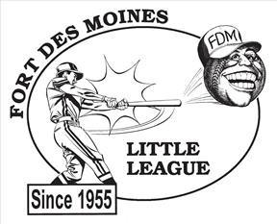

P.O. BOX 35361

DES MOINES, IA 50315

Dear Supporter of Fort Des Moines Little League,

Although baseball season is still months away, we here at Fort Des Moines Little League are in full swing of gearing up for our next season! The coaches and volunteers at FDMLL are committed to developing our participating youth by instilling teamwork, commitment, respect and hard work, all while teaching them the fundamentals of baseball. But we cannot do this without your help.

Sponsorship is a crucial part of our organization. The money raised helps us cover the cost of uniform, equipment, umpires, field maintenance, scholarships, and many other costs associated with running a quality program. Fort Des Moines Little League would like to invite you to become part of our fantastic program and ask for your support. The 2025 season is a special one for us as we will celebrate our 70th year of providing little league baseball on Des Moines Southside and surrounding areas. We are raising funds to celebrate all the alumni that have been a part of the Fort Des Moines Baseball family over the past 70 years! Keep an eye out for updates on events and celebrations throughout the 2025 Baseball season to honor all the Fort Des Moines families that have made the ballpark what it is today!

Attached you will find the sponsorship form with the various levels of participation. Please keep in mind that your donation will continue to allow us to offer an affordable program to our youth and allow families who cannot afford for their child to participate a chance to play. Plus, your donation is 100% tax deductible as we are a 501(c)3.

We want to thank you for your continued support of Fort Des Moines Little League and hope you will consider sponsoring our great program! We hope to see you around the ball fields this summer!

Sincerely,

Michael Drey, President

Fort Des Moines Little League

**FDMLL Sponsorship Form**

*Fort Des Moines Little League is a 501(c)(3) Non-Profit Charitable Organization and donations are tax deductible (EIN 23-7006448).*

**⬜ The Single $300** 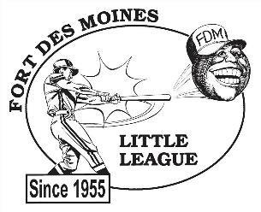

* Business name on one team’s jerseys
* Company thanked during daily announcements

**⬜ The Protected Player $450**

* Business name on one team’s jerseys
* Company thanked during daily announcements
* One player of your choice guaranteed (with parent permission)

**⬜ The Double $550**

-Business name on one team’s jerseys

* 3'x6' color banner on outfield fence
* Company’s name thanked during announcements
* Name and link listed on homepage fdmll.org

⬜ **The Triple $800.00**

* Business name on two team’s jerseys
* 3'x6' color banner on outfield fence
* Company’s name thanked during announcements

- Name and link listed on homepage fdmll.org

⬜ **The Home Run $1,250.00**

- Business name on three team’s jerseys

- Adoption of field with 4x8 banner stating: “Welcome to (Company Name) Field”

- 3'x6' color banner on outfield fence

- Company’s name thanked during daily announcements

- Name and link to company homepage listed on fdmll.org

**Sponsor Information:**

Name______________________________________________________________________

Address____________________________________________________________________ City________________________________ State_____________Zip Code_______________

Business name as you would like it to appear on jerseys:_____________________________

If you would like your name on a specific team, please list team name here: _____________

**Contact person for advertising information (logos, banner info, etc.):**

Name__________________________________Phone#______________________________

Email_______________________________________________________________________

Website Address______________________________________________________________

**Please email or mail the completed form to FDMLL by March 1st.**

[fdmlittleleague@gmail.com](mailto:fdmlittleleague@gmail.com) or PO Box 35361 Des Moines, Iowa 50315

Payments may be mailed or sent via Venmo @FortDesMoines-LittleLeague-1

**If you have any questions or wish to discuss further opportunities, please email fdmlittleleague**[**@gmail.com**](mailto:FDMLittleLeague@gmail.com)